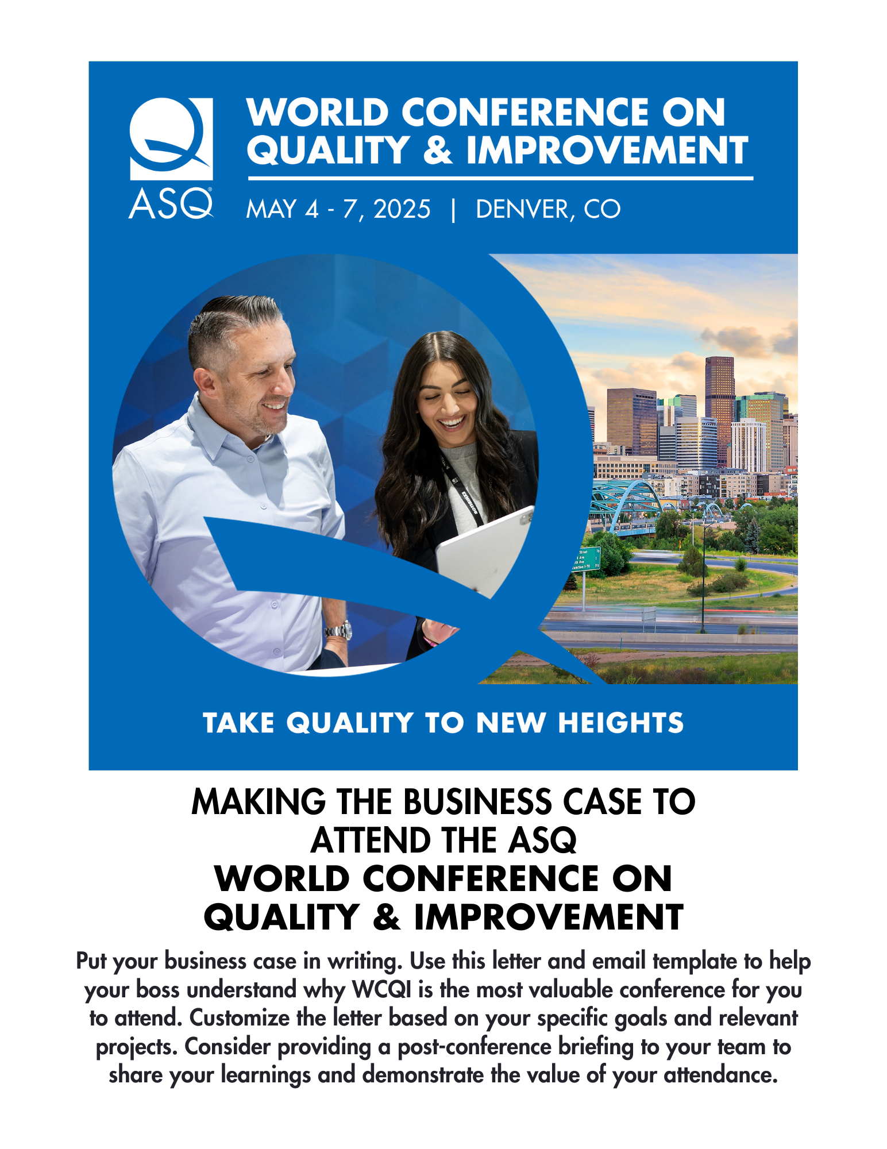

Dear [Insert Manager’s Name],

I’m writing to seek your approval to attend the [American Society for Quality’s (ASQ)](https://asq.org/) World Conference on Quality & Improvement (WCQI), May 4-7, 2025, in Denver, Colorado.

WCQI attendees will join passionate professionals to take quality to new heights. This event is more than just a meeting point; it's a gateway to using quality concepts and tools in new and unique ways every day and expanding the reach of quality practices into non-traditional industries and environments.

Through WCQI’s captivating sessions and thought-provoking discussions, attendees will:

* **Elevate** human performance within the context of quality by learning how to motivate your workforce to take production from mediocre to extraordinary.
* **Mapping** existing processes to identify bottlenecks, inefficiencies, and opportunities for improvement. Processes define everything we do in an organization.
* **Delve** into the use of data analytics tools and dashboards to gain insights, identify trends, and make data-driven decisions for quality improvement.

The conference offers a significant return on investment – for example, I can see an opportunity to apply what I will learn on [describe project or goal here].

Furthermore, the benefits of fostering a work culture where employees have opportunities to upskill are plentiful. According to [LinkedIn Learning](https://learning.linkedin.com/resources/upskilling-and-reskilling/upskilling-vs-hiring), providing these opportunities makes employees 3.5 times more likely to believe that their company can help them meet their career goals, contributing to employee retention as well as an energized and engaged workforce. Upskilling is also widely reported to boost employee productivity, according to a [PwC survey](https://proedge.pwc.com/upskilling-productivity-collaboration-and-growth).

Thanks for considering my request. If able to attend, I’ll be sure to share key takeaways and tangible ideas to apply what I’ve learned in order to leverage technology, build a people-first workplace, and expand quality best practices organization-wide.

Sincerely,

[Your name]

Subject line: Take Quality to New Heights

Body of email:

Dear [Insert Manager’s Name],

I’m writing to seek your approval to attend the [American Society for Quality’s (ASQ) 2025 World Conference on Quality & Improvement (WCQI)](https://asq.org/conferences/wcqi), scheduled from May 4-7, 2025.

As described in the attached letter, WCQI attendees will be able to join passionate professionals in taking quality to new heights. This event is more than just a meeting point; it's a gateway to using quality concepts and tools in new and unique ways every day and expanding the reach of quality practices into non-traditional industries and environments.

I’m confident my participation will allow me to bring back proven solutions that lead to personal growth, team development, and organizational success.

After reviewing the attached letter, please let me know if you have any questions or if we can discuss further.

Thank you for considering my request,

[Your name]

[Learn More and Register](https://asq.org/conferences/wcqi)