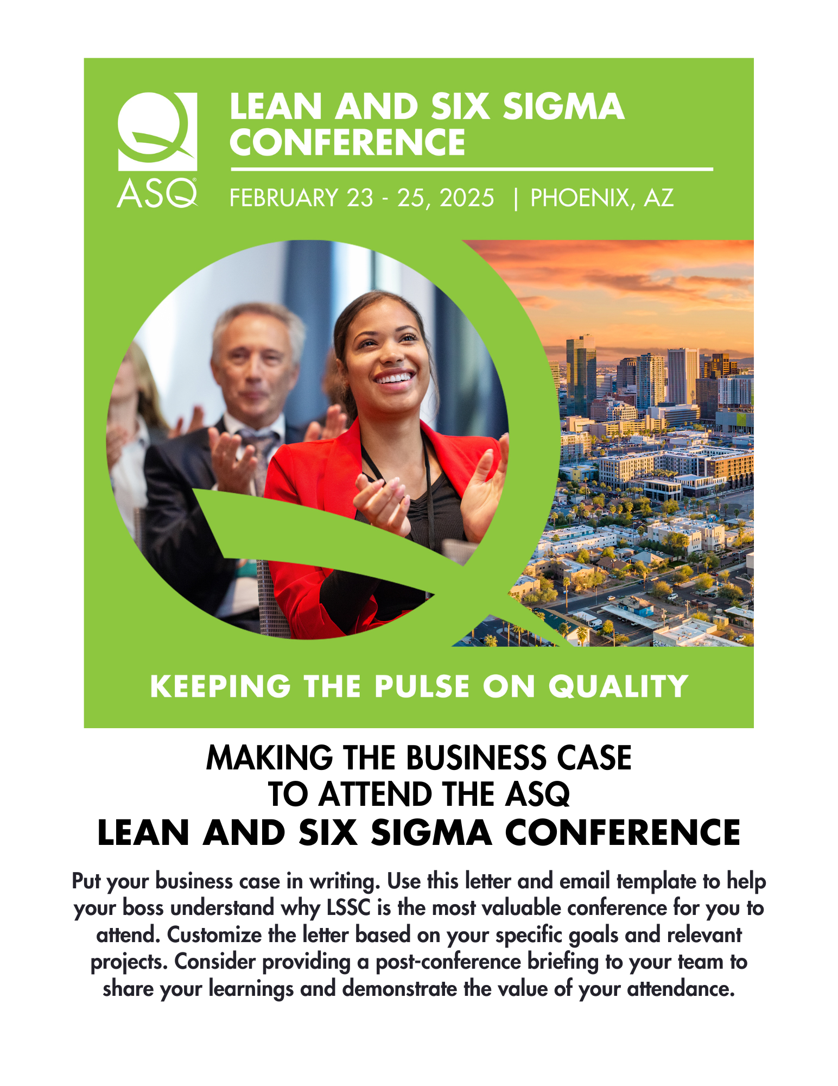

Dear [Insert Manager’s Name],

I’m writing to seek your approval to attend the [American Society for Quality’s (ASQ)](https://asq.org/) Lean and Six Sigma Conference (LSSC), beginning February 23, 2025, in Phoenix, Arizona.

LSSC attendees will learn to apply proven tools and leverage innovative technology, gain insight from peers and Case Studies, and upskill in lean and Six Sigma methodologies that lead to personal growth, team development, and organizational success. This event is more than just a meeting point; it's a gateway to the empowerment of quality professionals and people leaders to expand their contributions beyond daily problem-solving to realize lasting organizational excellence.

Through LSSC’s captivating sessions and thought-provoking discussions, attendees will:

* **Enhance** their expertise and develop their team through sessions on belt progression, effective leadership, and people-resource management to build a people-first workplace.
* **Master and share** basic tools, principles, and methodologies – including lean, Six Sigma, and Agile – to expand quality best practices organization-wide.
* **Leverage** technology to overcome large or messy data sets to ensure data integrity, quantify impact, analyze data, and learn how to use AI to help achieve your business goals and communicate relevant results to grow your organization’s appreciation of the value of data.

The conference offers a significant return on investment – for example, I can see an opportunity to apply what I will learn on [describe project or goal here].

Furthermore, the benefits of fostering a work culture where employees have opportunities to upskill are plentiful. According to [LinkedIn Learning](https://learning.linkedin.com/resources/upskilling-and-reskilling/upskilling-vs-hiring), providing these opportunities makes employees 3.5 times more likely to believe that their company can help them meet their career goals, contributing to employee retention as well as an energized and engaged workforce. Upskilling is also widely reported to boost employee productivity, according to a [PwC survey](https://proedge.pwc.com/upskilling-productivity-collaboration-and-growth).

Thanks for considering my request. If able to attend, I’ll be sure to share key takeaways and tangible ideas to apply what I’ve learned in order to leverage technology, build a people-first workplace, and expand quality best practices organization-wide.

Sincerely,

[Your name]

Subject line: Keeping the Pulse on Quality

Body of email:

Dear [Insert Manager’s Name],

I’m writing to seek your approval to attend the [American Society for Quality’s (ASQ) 2025 Lean and Six Sigma Conference (LSSC)](https://asq.org/conferences/six-sigma), scheduled from February 23, 2025, through February 25, 2025.

As described in the attached letter, LSSC attendees will learn to apply proven tools and leverage innovative technology, gain insight from peers and Case Studies, and upskill in lean and Six Sigma methodologies that lead to personal growth, team development, and organizational success

I’m confident my participation will allow me to bring back proven solutions that lead to personal growth, team development, and organizational success.

After reviewing the attached letter, please let me know if you have any questions or if we can discuss further.

Thank you for considering my request,

[Your name]

[Learn More and Register](https://asq.org/conferences/six-sigma)