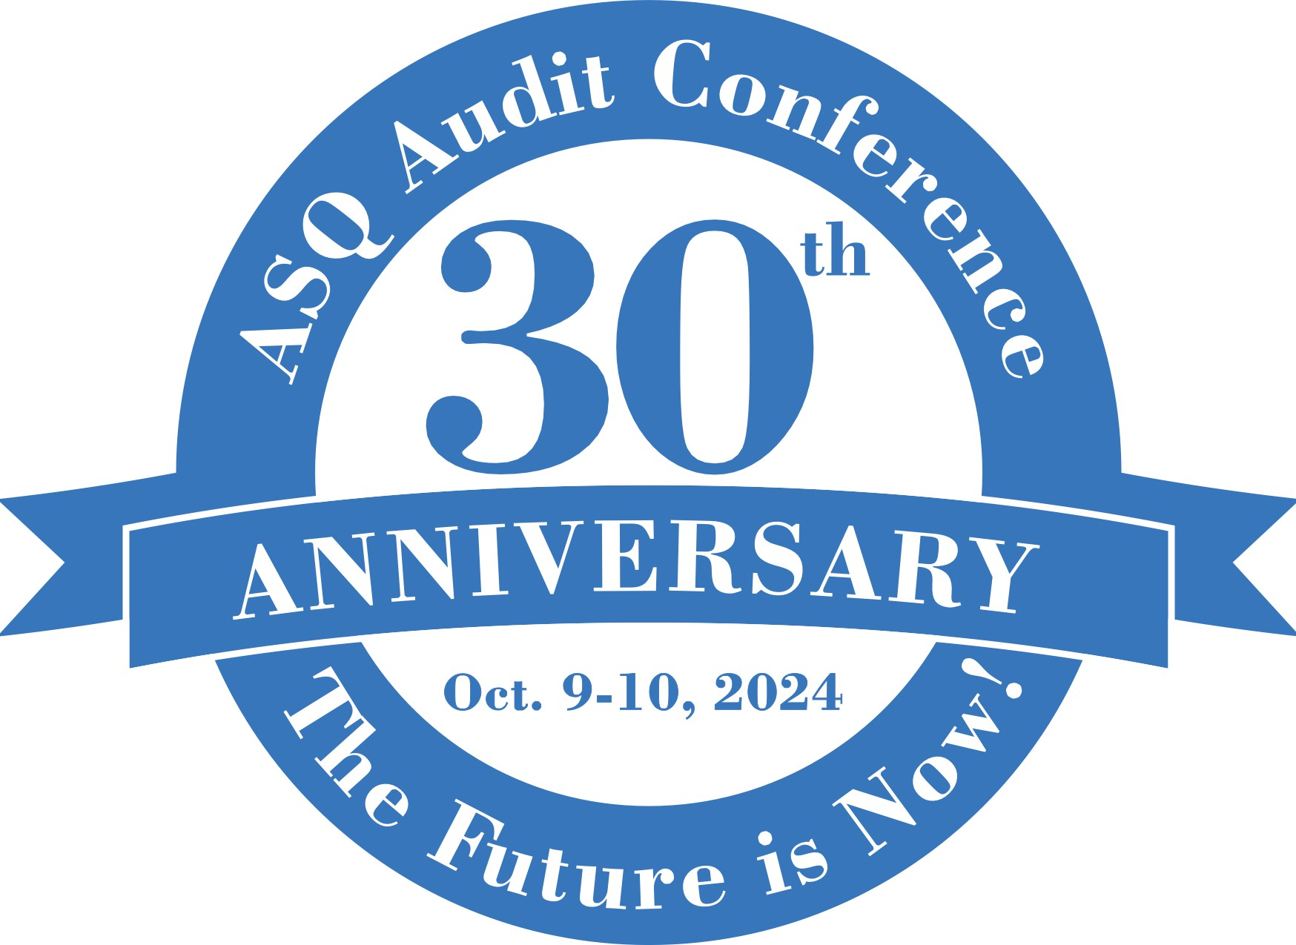

MAKING THE BUSINESS CASE
to attend the 2024 ASQ Audit Division Conference

Put your business case in writing. Use this letter and email template to help your boss understand why the 2024 ASQ Audit Division Conference is the most valuable conference for you to attend. Customize the letter based on your specific goals and relevant projects. Consider providing a post-conference briefing to your team to share your learnings and demonstrate the value of your attendance.

Dear [Insert Manager’s Name],

I’m writing to seek your approval to attend the American Society for Quality’s 2024 Audit Division Conference | ASQ scheduled for October 9-10 in Reno, NV.

The Audit Division Conference continues to connect professionals at all stages of our careers to the processes, technologies, and experts that can deliver sustainable results for our organizations.

Through the Conference immersive workshops, expert speaker sessions and Q&As, which include basic, intermediate, and advanced levels, attendees will dive into such topic areas as:

- The Future is Now – and – It Will Evolve
  - How auditors can help auditees change for the better
  - Winning the trust of business leaders so they will listen to you! Essentials for the quality professional
  - What every auditor should know about - Data analytics and information security (covering some points from ISO 27001)
  - Five key tools will make audits and reports easier.

- The Auditor's New Role: Continual Learner!
A person that audits can find themselves stuck between a rock and hard place with continued changes in audit methods and the growing number of management standards. Choosing the right audit method can help a company meet performance and standard conformance goals. Learn how best to consolidate multiple standard requirements like Quality and Cybersecurity and on how to diversify the audit program by incorporating remote auditing and defining the auditor's new responsibility.

- Tools and Beacons
Experts will provide guidance for how to take advantage of the classic tools and be ahead of the curve on the new technologies coming to the market.

Discounted hotel room rates starting at $140 a night (excluding taxes) are in effect until September 1, or sold out. Factoring in airfare of [estimate], my attendance would cost an estimated [total].

The conference offers significant return on investment – for example, I can see an opportunity to apply what I will learn on [describe project or goal here].

Furthermore, the benefits of fostering a work culture where employees have opportunities to upskill are plentiful. According to LinkedIn Learning, providing these opportunities make employees 3.5 times more likely to believe that their company can help them meet their career goals, contributing to employee retention as well as an energized and engaged workforce. Upskilling is also widely reported to boost employee productivity, according to a PwC survey.

Thanks for considering my request. If able to attend, I’ll be sure to share key takeaways, best practices, and tangible ideas to apply what I’ve learned in order to help our team meet present and future challenges with customized and sustainable quality solutions.

Sincerely,
[Your name]

Subject line: The World’s leading Quality Audit Conference

Body of email:
Dear [Insert Manager’s Name],

I’m writing to seek your approval to attend the American Society for Quality’s 2024 Audit Division Conference scheduled for October 9-10 in Reno, NV.

As described in the attached letter, quality professionals at all career stages have attended this conference for more than 25 years–making it an exceptional opportunity to build connections and to explore the proven processes, technologies, and experts that can deliver sustainable results.

I’m confident my participation will allow me to bring back proven solutions for our unique organizational needs, helping our team meet the challenges of today and tomorrow.

After reviewing the attached letter, please let me know if you have any questions or if we can discuss further.

Thank you for considering my request,
[Your name]

