
32nd ASQ Audit Division Conference
(in collaboration with the ASQ Food, Drug, and Cosmetic Division)

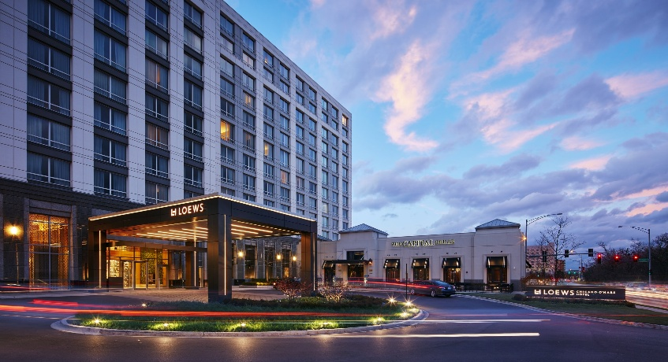

September 23-24, 2026
being held at the
Loews Chicago O’Hare Hotel – Rosemont, IL

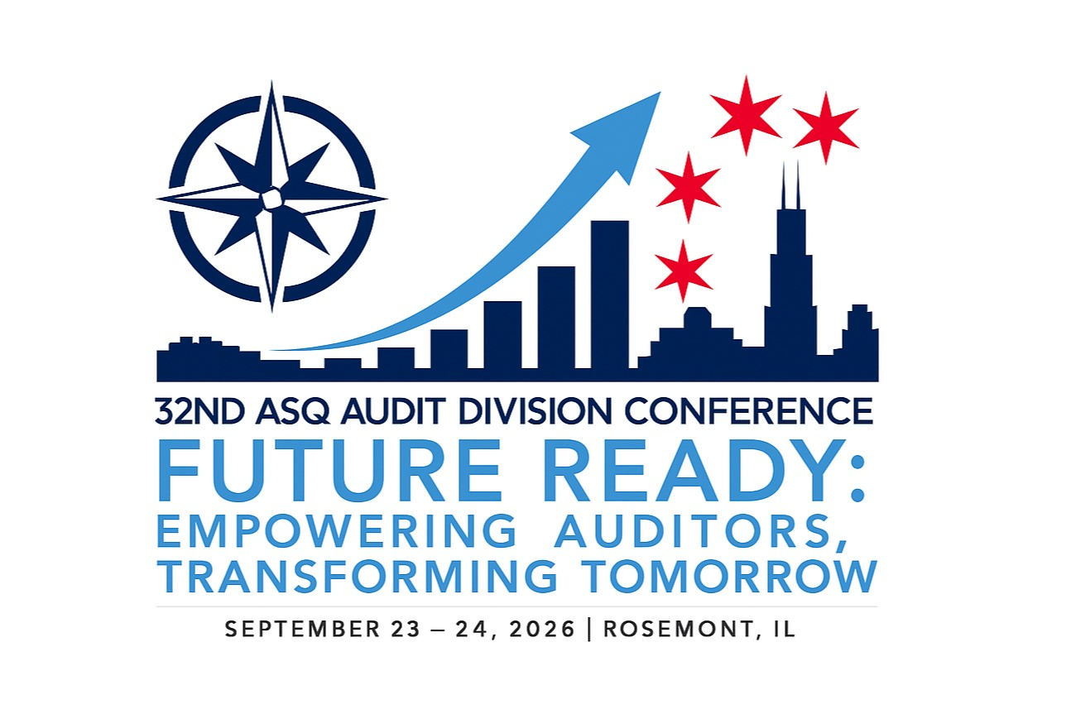

2026 ASQ Audit Division Conference Sponsor Levels and Benefits
Benefit | $5000 (Minimum)  Diamond Sponsor | $4000 (Minimum)  Platinum Sponsor | $3000 (Minimum)  Gold Sponsor | $1000 (Minimum)  Silver Sponsor
Acknowledgement as a Conference Sponsor at general events associated with the conference will include level of Sponsorship (i.e., “Diamond” “Platinum”, “Gold”, “Silver” Sponsor) | X | X | X | X
Branding space on the ASQ Audit Division Conference website | X (4”x4”) | X (4”x2”) | X (2”x2”) | X (2”x1”)
Logo on the Conference Program, and Slideshow | X | X | X | X
6 or 8 foot table for your material at the Conference | X | X | X
Complimentary conference registrations including meals and gala (a $1200 / each value) | 2 | 2 | 1
15-minute speaking opportunity during the Conference | X
10-minute speaking opportunity during the Conference |  | X

Early Bird Sponsor Opportunity
**5% Discount on All Sponsor pricing through february 28, 2026**

Enter Discount Code eARLYSPONSOR AT THE lINK BELOW:
Member Planet

The earlier you make your commitment to be a sponsor, the more exposure your organization will receive. Pre-conference marketing includes top sponsors on all pre-conference advertising, division newsletter, and conference website.

For Complete Information About Sponsorship Opportunities Please Contact:

Andrew Davison at: andrew_davison@att.net

Introduction  The ASQ was founded in 1946 and has provided members and their organizations with the resources to achieve performance excellence. Its members have initiated most of the quality methods used throughout the world. The mission of ASQ is to facilitate continuous improvement and increased customer satisfaction by identifying, communicating, and promoting the use of quality principles, concepts, and technologies, and thereby being recognized as a worldwide authority on quality. The ASQ Audit Division, founded as a Technical Committee in 1975, is an extension of this quest to be the premier resource for quality and all things auditing.  The ASQ Audit Division is host to a team of professionals interested in learning more about and advancing auditing as a profession, with a peer network of more than 13,000 individuals from around the world. The ASQ Audit Division provides a venue where all can network with people who do similar work and have a common interest in performance excellence. The primary objective of the ASQ Audit Division is to promote broader application and use of quality auditing principles for effective business management purposes.  Each year we work to improve and provide the best conference available. We are looking for innovative ways to provide as much information and networking opportunities as we can at a 2-day conference.  This year’s conference (in collaboration with the ASQ Food, Drug, and Cosmetic Division), is being held at the Loews Chicago O’Hare Hotel in Rosemont, IL. This hotel features numerous first-class amenities, free services, and an unrivalled location for an unforgettable stay. Providing the best hotel service and amenities is an art that Loews Hotel has perfected over 50 years. Loews Hotel holds the AAA Four Diamond rating for hospitality industry excellence.  The ASQ Audit Division offers high impact sponsorships that enable companies like yours to contribute to the success of the division and the conference while gaining priceless exposure for your products and services. While reaching your target audience, your company will gain lasting recognition. Your affiliation with the Audit Division Conference will serve as a constant reminder of your commitment to quality. | Key to Our Success  Each year, one of the keys to our success is the invaluable contributions of our sponsors. For those of you who have supported the Division and the Conference in the past, we thank you for your continued support. For those of you who will be taking advantage of this excellent opportunity for the first time, welcome!  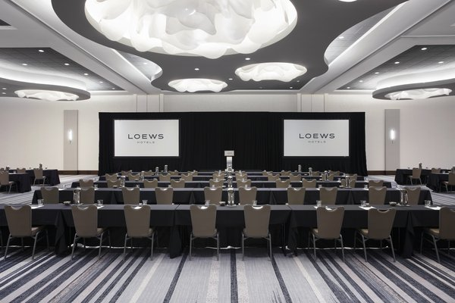  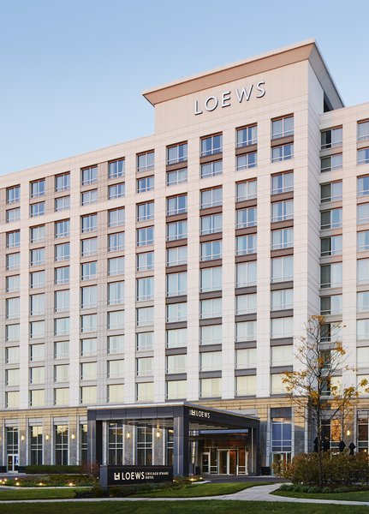
  Conference Overview
  To achieve effective results, auditors are expected to influence managerial decision making with their audit findings. This conference focuses on the auditor’s role in identifying quality system issues to improve performance & processes, revenue, and customer satisfaction, including management planning and the decision-making process. It is also the objective of this conference to keep auditors exposed to realizing and managing risks specific to quality, changes to standards, innovations in communications, and ever-changing material, approaches, and techniques, in the auditing discipline.

