Thank you to our Diamond Sponsor
BPA Solutions

Thank you to our Gold Sponsor
Quality Support Group

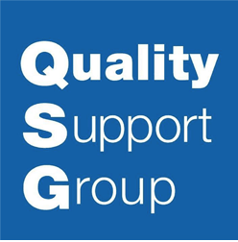

Thank you to our Gold Sponsor
Business Excellent Professional Consulting

Thank you to our Gold Sponsor
Quality Digest

Thank you to our Gift-in-Kind Sponsor
QI Macros

Thank you to our Gift-in-Kind Sponsor
Heather Wade - Heather Wade Group

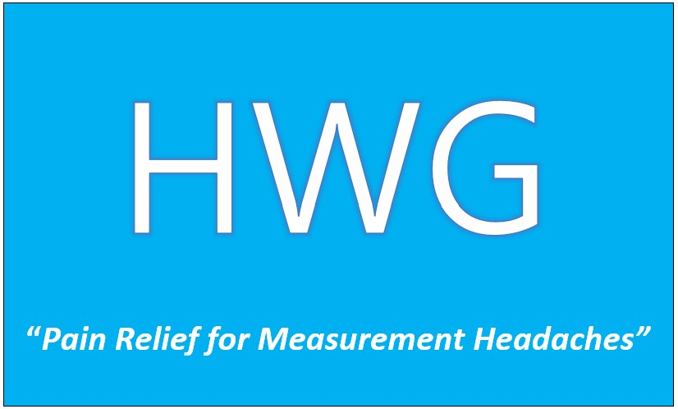

Thank you to our Gift-in-Kind Sponsor
Erin Urban - UPP Solutions

